**Summer 2023: CS5710 – Machine**

**Learning**

**In-Class Programming Assignment-1**

**Anudeep Allamsetty - 700741171**

**1. Numpy:**

1. Using NumPy create random vector of size 15 having only Integers in the range 1-20.
   1. Reshape the array to 3 by 5
   2. Print array shape.
   3. Replace the max in each row by 0

Create a 2-dimensional array of size 4 x 3 (composed of 4-byte integer elements), also print the shape, type and data type of the array.

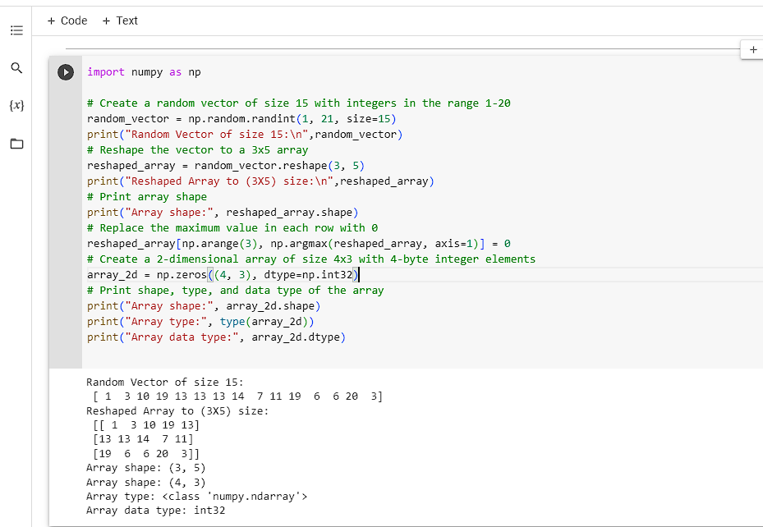

In the above code we import the numpy library which provides functions for working with arrays and mathematical problems. In order to generate the random number we use randint function which belongs to random module. Randint function generates the random numbers with the specified range with the specified size. Then we use reshape function to reshape the vector with the specified dimension without modifying the elements in the vector. Using the shape attribute, we output the modified array's shape. Since the array in this example has 3 rows and 5 columns, the shape informs us of its dimensions, which in this case would be (3, 5). To get the indices of the highest value in each row of the reshaped array, we utilize the np.argmax() function. The function argmax() returns the index of the greatest element along a given axis. This tells us where the highest value in each row is located. The maximum values in each row are changed to 0 using the indices we acquired. The corresponding rows are chosen, and their maximum values are set to 0, using the np.arange(3) function and the acquired indices. Next, we use np.zeros() to construct a new 2-dimensional array called array_2d. This function generates an array that contains just zeros. The array will contain 4 rows and 3 columns if its size is specified as 4x3.We print the shape of array_2d using the shape attribute. This will give us the dimensions of the array, which is (4, 3) in this case.We also print the type of array_2d using the type() function. It tells us that the array belongs to the ndarray class, which is provided by NumPy.Finally, we print the data type of the array using the dtype attribute. In this case, the array has a data type of int32, which means it contains 4-byte integers.

1. Write a program to compute the eigenvalues and right eigenvectors of a given square array given below: [[3 -2] [ 1 0]]

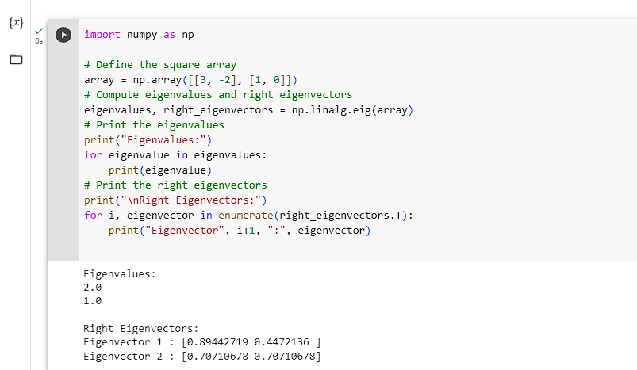 We use the np.array() function to define the square array. Assigning the array is [[3, -2], [1, 0]].To determine the array's eigenvalues and right eigenvectors, we utilize the np.linalg.eig() function. The array is the input for the eig() function, which outputs right eigenvectors and eigenvalues.Using a loop, we print the eigenvalues. We print each eigenvalue from the array of eigenvalues separately.The resulting 2-dimensional array contains the right eigenvectors. The array's columns each correspond to a separate eigenvector.We employ another loop to print the appropriate eigenvectors. We print each column (or eigenvector) in the array of right eigenvectors separately.The eigenvectors are normalized to 1, with their magnitudes scaled to unit length.

1. Compute the sum of the diagonal element of a given array.

[[0 1 2]

[3 4 5]]

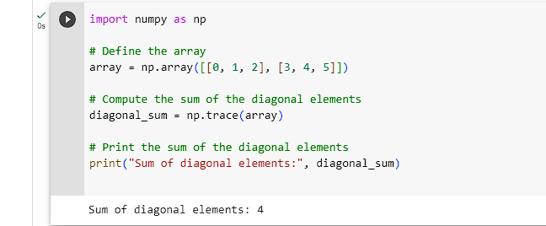

To calculate the total of the diagonal array members, we utilize the np.trace() function. The primary diagonal of an array, which runs from top-left to bottom-right, is referred to as the diagonal element.The diagonal elements of a 2-dimensional array's sum are computed using the np.trace() function. In this instance, it calculates the diagonal array's sum of items.In the variable diagonal_sum, we keep the total of the diagonal elements.Using print(), we display the diagonal elements' total. In this instance, the total is 4.

1. Write a NumPy program to create a new shape to an array without changing its data.

Reshape 3x2:

[[1 2]

[3 4]

[5 6]]

Reshape 2x3:

[[1 2 3]

[4 5 6]]

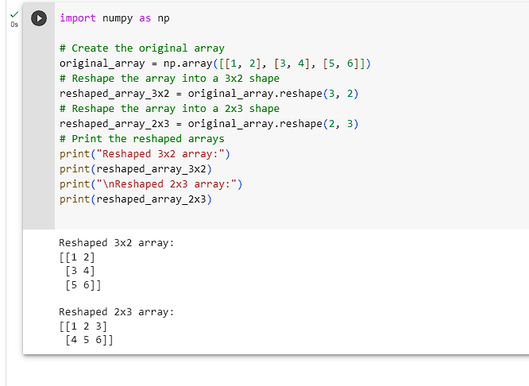

Two reshaped arrays, reshaped_array_3x2 and reshaped_array_2x3, are made using the reshape() function.We can change the shape of an array without changing its data by using the reshape() function. We use the original array to invoke this function, passing the required shape as an argument.The variables reshaped_array_3x2 and reshaped_array_2x3 contain the reshaped arrays, accordingly.

**2. Matplotlib**

* 1. Write a Python programming to create a below chart of the popularity of programming Languages.
  2. Sample data:

Programming languages: Java, Python, PHP, JavaScript, C#, C++ Popularity: 22.2, 17.6, 8.8, 8, 7.7, 6.7

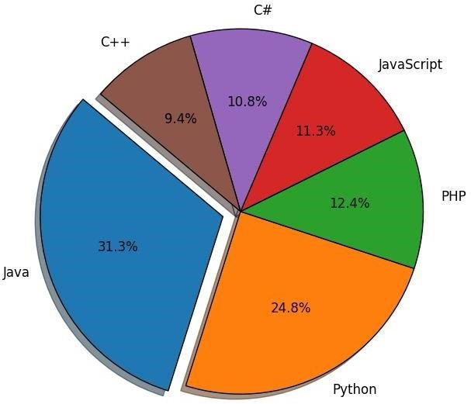

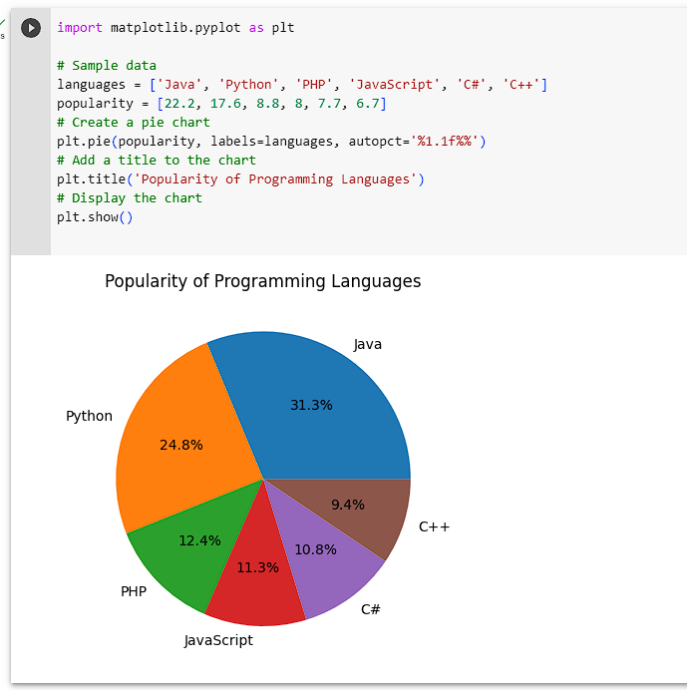

We begin by importing the pyplot module from the Matplotlib library, which offers tools for making visualizations.Languages and popularity are the two lists that we define. These lists show the programming languages and their corresponding popularity scores. For instance, the popularity of "Java" is 22.2%, "Python" is 17.6%, and so on.To make a pie chart, we employ the plt.pie() function. This function accepts the popularity list as input for the chart data and the labels argument for the programming language names.The percentage numbers presented on the chart are formatted using the autopct parameter. To indicate one decimal place for the percentage numbers in this instance, we use the notation "%1.1f%%".